Free Youtube views for an unlimited number of your videos! Boost your video's popularity using their simple and free method! Or, buy Youtube views and other services here.

[ythunder.com](https://ythunder.com/) has free & open registrations.

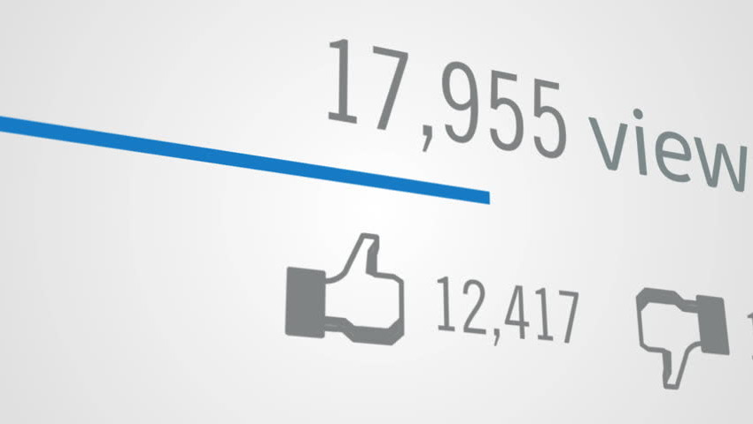

With [YouTube](https://ythunder.com/) flourishing and more [YouTuber](https://ythunder.com/)s emerging from every corner of the world, it’s extremely difficult to attract viewers to your videos and acquire more views.

Free Youtube views：[ythunder.com](https://ythunder.com/)

Hence, more and more people are opting to buy views on [YouTube](https://ythunder.com/) to boost their fan base and put this perception of recognition out there. Its noted that buying view helps increase the authentic growth of your channel when it comes to views, likes or subscribers.

The perception is key that you’re established enough to be followed. A low fan base is highly unlikely to attract more followers. People shy away from being the initial subscribers and ‘clickbait’ is very much active on [YouTube](https://ythunder.com/).

Videos with more views are more attractive to most viewers and this, in turn, generates traffic. If you’re under the impression that most [YouTube](https://ythunder.com/) stars don’t buy likes or views then you’re sorely mistaken. Content is king of course but with different topics ‘trending’ daily, it’s difficult to remark what’ll create more traffic and what won’t.

The myth that ‘buying’ views is an unethical practice is just Free Youtube views：[ythunder.com](https://ythunder.com/)

that, a myth. Most [YouTuber](https://ythunder.com/)s have been privy to such practices and it’s a simply a push to get the ball rolling.

|  |  |  |  |
| --- | --- | --- | --- |
| **Top 3 Recommended Sites** | **Ratings** | **Try** | **Customer Reviews** |
| #1. YTHunder | 4.8 | Visit website | Read Reviews |
| #2. Famoid | 4.5 | Visit website | Read Reviews |
| #3. FastLykke | 4.2 | Visit website | Read Reviews |

We reviewed 10 best-paid sites to buy [youtube](https://ythunder.com/) likes, views, and subscribers from so it’s easier for you to choose.

**1. YTHunder – Recommended**



Read Follower Packages Customer Reviews

**Rating: 4.9 out of 5**

One of the most reliable sites we encountered, follower packages provides the highest quality of views available in the market. This means you’ll get a well analyzed personalized service that will help you improve your social media rankings and grow your channel.

They’ll help increase your credibility on [YouTube](https://ythunder.com/) as well as other platforms according to your needs at the best prices. This website is the lowest priced premium provider on this list but doesn’t compromise on quality, this combination means it’s accessible to almost anyone!

The site also offers safe transactions through their SSL secured checkout and was quick to deliver when it came to quality views and video likes. Follower Packages provides services in [YouTube views](https://ythunder.com/), [YouTube](https://ythunder.com/) Likes, Instagram Followers and SoundCloud Plays among others.

Anything and everything you need under one umbrella. Another key feature provided is 24/7 live-chat, this means you will always get your questions answered fast. By working with high profile clients such as celebrities and influencers, they have established themselves as a market leader.

If you are seeking the best quality views and video likes at the best possible prices, this is the clear choice!

**2. Famoid**

6FCB3C47FCA44649B6B6D45AE4B874BE.png

Read Famoid Customer reviews

**Rating: 4.5 out of 5**

This site was a bit more on the pricier side. Famoid offers help for exponentially growing your social media following to improving your reputation.

They provide services on [YouTube](https://ythunder.com/), Twitter, Soundcloud, Pinterest, Linkedin, and Vimeo. If you’re choosing to promote your business through [YouTube](https://ythunder.com/), then Famoid is a good investment option for you. From providing services like, buying real [Youtube subscribers](https://ythunder.com/) to spiking the numbers of likes on videos, Famoid has you sorted.

They’ve created stars out of Artists, Musicians, Directors, Companies, Corporations, etc. so we know they mean business.  This site practices ‘you get what you pay for’, it’s worth checking out if you can’t afford the more premium services.

**3. FastLykke**



Read Fastlykke Customer Reviews

This website provides every service for [YouTube](https://ythunder.com/) in one place. It’s convenient and also difficult to choose from all the options. Fastlykke ranges from $9 to about $60, deeming it the priciest one on the list. They offer premium as well as basic content.

Most people make the mistake of choosing the wrong company when it comes to buying more [Youtube](https://ythunder.com/) likes, views, subscribers, etc. This website will attempt to increase your popularity by getting views from organic accounts. They promise cheap rates but quality content. However, if you want to boost your account, you need to pay the big bucks.

**4. Venium**

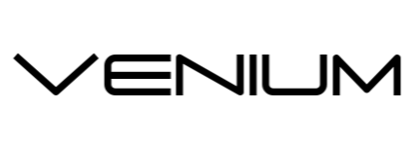

Paying for views is the best way to generate traffic to your video because they’ll serve as a channel that’ll help you develop a distinguished position in the [YouTube](https://ythunder.com/) industry. Venium offers 100% real and pre-screened users. Once you make your purchase the views are added steadily over time to make sure the procedure is safe.

They help you grow your online presence by bringing you an audience immediately which enables you to gain an even larger audience for your product/business. They also follow an efficient method of gaining exposure on your [YouTube](https://ythunder.com/) and you can get it simply by paying. This may be a good option for someone who wants a slow campaign at a mid-range cost.

**5. GetRealBoost**

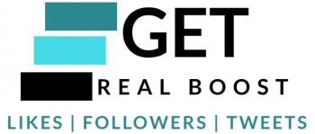

This website deals with [YouTube Views](https://ythunder.com/) along with Instagram, Twitter, Soundcloud, and Facebook. Anything and everything for social media is here including likes, shares, comments and subscriptions.

They provide comprehensive [YouTube](https://ythunder.com/) optimized packages which boost your account’s ranking and ensure that your content is seen.

The prices are on the affordable level and can be tested with a low initial investment. They also promise that the order of a certain package comes with free likes but we wouldn’t trust if the likes are real or not. The prices range from $5 to $2500, you choose your package with a good price breakdown for you to analyze.

**6. GetFans.io**



GetFans.io offers [YouTube views](https://ythunder.com/) at good pricing and support to customers.

There is a social formula that gives you a leg-up on the social media ladder and this website can help you if you’re looking for a [YouTube](https://ythunder.com/) boost. It’s a good promotional tool to get your business noticed.

The site also offers help with Instagram followers and likes. They don’t offer a lot of things but if you’re just starting out then it’s not a bad place to begin. GetFans also claims to adopt a 100% white hat approach.

**7. BRSM**

D71F7FB25BBD417AB88DF114E89B6863.png

All these websites promise that they’re engaging in ‘real’ accounts which means there will be actual people operating accounts that like or view your product. And BRSM is one of them. They’re offering wide range of services from where you can [buy YouTube views](https://ythunder.com/), likes, subscribers and comments and also customize the package you buy.

The prices are a bit on the pricier side and we found it a one-time investment if none at all. Their return and privacy policies are pretty tight including their payment methods. All the websites on this list are safe and reliable to try.

Research studies show that having a large number of social statistics will make visitors 40% more curious about your content so buying [YouTube views](https://ythunder.com/) is commonplace and nothing to shy away from.

**8. QQtube**



This website claims to be #1 [YouTube](https://ythunder.com/) view supplier but we’ll be the ones to decide that for you. They have services in [YouTube](https://ythunder.com/) and Instagram. The site claims to never deliver fake views. They listen to customer demands and deliver accordingly and that’s quite appreciative of them.

They also ensure the virality of your video but we were skeptical about that. The results were quick and the price range is pretty reasonable but you need to order a minimum amount of certain things (likes, comments, etc) so there’s that. Their price breakdown is also pretty simple to decipher as well. But you be the judge of whether you’re getting what you paid for.

**9. Social Noor**



Social Noor deals with just [YouTube](https://ythunder.com/) so if that’s what you’re looking for then this is a place to start. This website offers ‘targeted [YouTube views](https://ythunder.com/)’ which means you’ll get high-quality real [YouTube](https://ythunder.com/) Targeted views to your videos in a few hours. This website spans over 30 countries and also offers worldwide views along with subscribers, likes, dislikes, and comments.

The prices start with $5 and go up to $45. They also ensure fast delivery and privacy protection which most websites on this list do. But you still need to choose wisely when it comes to purchasing likes, views, etc.

Most people are skeptical about purchasing likes, comments, subscribers, etc. thinking it’s unethical or furthermore illegal. It’s none of the two. These are marketing strategies that you need to employ to improve your social media presence on all platforms, [YouTube](https://ythunder.com/) isn’t any different.

Also Read:10 Best Sites to Buy Real & Active Twitter Followers in 2018

**10. SUBSSHOP**



[YouTube](https://ythunder.com/) is a social platform which is always in trend. After the algorithm update of [YouTube](https://ythunder.com/), all the [YouTuber](https://ythunder.com/)s were struggling to get

genuine subscribers. Their search comes to an end with where they can get high quality services to gain new subscribers.

They do offer best competitive packages and the best email customer support system to serve its clients at their best. It is a trustworthy

site that gives 100% guarantee and provide loyal subscribers.

Kickstart your social stardom with SUBSSHOP by using their services for

* Fast [YouTube Subscribers](https://ythunder.com/)
* Instagram Services
* Twitter Services

While we have successfully managed to scour the internet to bring the best to you, we understand that you still might have some questions at the back of your mind. Below we’ve tried to answer some of the most basic questions a customer faces while making this decision.

***Can you really buy*** [***YouTube subscribers***](https://ythunder.com/)***?***

Yes, buying [YouTube subscribers](https://ythunder.com/), likes and views is easier than you think. Think of your favourite musician or actor, they’ve all bought some extra luck at some point in their lives.

***Why should I buy more*** [***YouTube subscribers***](https://ythunder.com/)***?***

To create a strong network with your audience, you will need as many subscribers as possible. You can instantly boost your following by buying [YouTube](https://ythunder.com/) followers and likes. Once you get more followers, [YouTube](https://ythunder.com/) will automatically suggest your video to more subscribers.

***Is it safe to buy*** [***YouTube subscribers***](https://ythunder.com/)***?***

It is safe as long as you are cautious and not compromising on the money spent to buy subscribers. Many sites and third-party apps will be luring to [buy YouTube views](https://ythunder.com/) and subscribers for cheap prices. You need to do your bit of R&D before falling for them as they could be potential hackers or frauds.

***Is it illegal to buy*** [***YouTube subscribers***](https://ythunder.com/) ***and likes?***

Its not at all illegal. However [YouTube](https://ythunder.com/) does not encourage such an activity but then, at the end of the day, it is not illegal.

***Will I get banned if I buy*** [***YouTube subscribers***](https://ythunder.com/)***?***

Your account is likely to get banned only when you are violating [YouTube](https://ythunder.com/)’s Terms of Service and uploading illegal content. [YouTube](https://ythunder.com/)’s TOS does not state buying more followers and likes as illegal.

***Are all bought*** [***YouTube subscribers***](https://ythunder.com/) ***bots?***

No, not all bought subscribers are bots. When it comes to buying views, some providers provide organic followers and views against other, who provide fake ones. This is where you need to be careful and should always aim for buying from legit service providers.

***Can I buy*** [***YouTube subscribers***](https://ythunder.com/) ***for cheap?***

You can buy [YouTube subscribers](https://ythunder.com/) from a number of providers for various package deals. Sites like Fastlykke and Social Noor offer packages starting from $9 to about $60 and from $5 and to $45 respectively.

All the above websites offer ‘real’ accounts that won’t challenge the credibility of your account, keeping your moral dilemma at bay. These purchases are simply an investment in getting your social media ball rolling.

They attract a much more organic audience than going the honest, patient way and that’s the reality of the trade. And with [YouTube](https://ythunder.com/) even more so as [YouTube](https://ythunder.com/) takes engagement rates into consideration while ranking content. The more users engage with your product, the higher it’ll rank you and the more traffic your content will receive in turn. It’s a win-win all around.

Free Youtube views for an unlimited number of your videos! Boost your video's popularity using their simple and free method! Or, buy Youtube views and other services here.

[ythunder.com](https://ythunder.com/) has free & open registrations.